**PROJECT BATCH:** 9 **Title:** AI Powered Mental Health Diagnosis System **Guide**: Mr. Md Sayad

**TL**: Sanala Bala Sree Varsha (21BQ1A42F5) **TM1**: Parasa Hari Sai (22BQ5A4213)

**TM2**: Sathiri Vyshnavi (21BQ1A42F8) **TM3**: Karumuru Jahnavi (22BQ5A4220)

Objective:  
To develop an innovative and accurate AI-powered system for mental health diagnosis using machine learning and natural language processing. The proposed solution aims to provide early detection, real-time monitoring, and personalized recommendations for mental health conditions while reducing the limitations of traditional diagnosis methods.

Abstract:  
 Mental health issues are becoming increasingly common around the world, but traditional diagnosis methods often involve long consultations and subjective evaluations, which can delay treatment. The *AI-Powered Mental Health Diagnosis System* uses the power of artificial intelligence specifically machine learning and natural language processing (NLP) to offer a faster, more accessible, and accurate way to identify mental health conditions.

Our system processes various inputs, like text responses, mood patterns, and data from wearable devices, to detect early signs of conditions such as depression, anxiety, and bipolar disorder. It includes features like quick self-assessments, tailored recommendations, real-time mood tracking, and alert systems to help individuals monitor their mental well-being.

By analysing diverse data sources including clinical records, patient conversations, and even social media interactions the system identifies patterns, trends, and emotional cues that may otherwise go unnoticed. Built to be user-friendly and culturally inclusive, it ensures privacy and security while improving early detection of mental health risks. By complementing existing healthcare services, the system reduces stigma, encourages timely interventions, and empowers individuals to take charge of their mental health journey.

## Keywords:

* Artificial Intelligence
* Machine Learning
* Natural Language Processing (NLP)
* Sentiment Analysis
* Emotion Detection
* Predictive Analytics
* Real-Time Monitoring
* Mental Health Assessment
* Mood Pattern Analysis
* Personalized Recommendations
* Mental Health Alerts
* Stress and Anxiety Monitoring
* Digital Mental Health Solutions
* Clinical Data Integration
* User-Centric Design
* Data Privacy and Security

## Existing System:

1. **Manual Diagnosis:** Relying on consultations and subjective assessments for mental health disorders.
2. **Self-Reports and Surveys:** Lack precision and real-time monitoring capabilities.
3. **Traditional Tools:** Limited use of AI or automation for analysing clinical and patient datasets.

## Disadvantages of Existing Systems:

* Lengthy and subjective assessment process.
* Absence of real-time mood monitoring and analysis.
* Limited access to tools for early diagnosis in underserved regions.
* High reliance on human resources for interpretation and evaluation.
* Lack of integration with wearable devices for consistent data gathering.

Proposed System:  
The proposed system integrates advanced AI and machine learning to detect and monitor mental health conditions efficiently.

* **Natural Language Processing (NLP):** Analyses user inputs (text, patterns, linguistics).
* **Machine Learning:** Identifies patterns from diverse data sources, including wearables and patient interactions.
* **Personalized Recommendations:** Provides tailored interventions and alerts for mental health risks.
* **Real-Time Monitoring**: Continuously tracks mood patterns for early detection of potential risks.
* **User-Friendly Interface**: Secure and accessible platform for all demographic groups.

## Advantages of Proposed System:

1. **Early Diagnosis:** Timely detection of mental health conditions reduces treatment delays.
2. **Real-Time Monitoring**: Tracks data from multiple inputs, including wearables and text.
3. **User Accessibility**: Designed to be culturally inclusive and easy to use.
4. **Integration with Existing Services**: Complements traditional healthcare systems.
5. **Data Privacy and Security:** The system ensures ethical, secure, and encrypted usage of sensitive mental health data, maintaining user confidentiality.

## List of Algorithms:

1. Natural Language Processing (NLP)
2. Sentiment Analysis (using Hugging Face Transformers, BERT)
3. Machine Learning Models:

* Decision Trees
* Neural Networks (ANN, LSTM for sequential data)

1. Emotion Detection Algorithms:

* Sentiment Intensity Analysis
* Recurrent Neural Networks (RNN)

1. Anomaly Detection:

* Autoencoders
* Isolation Forests

1. Clustering Algorithms:

* K-Means Clustering
* DBSCAN

## Block Diagram:

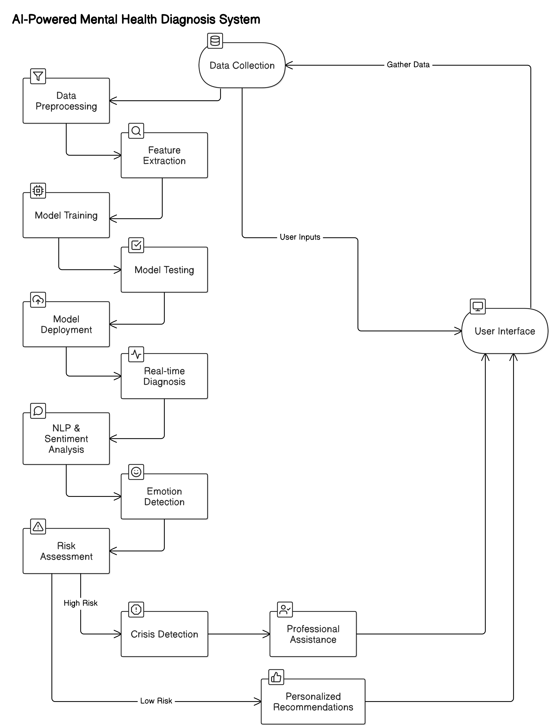

## Software Requirements:

* MERN Stack (MongoDB, Express.js, React.js, Node.js)
* Python (programming language)
* Jupyter Notebook (for data analysis and model development)
* Scikit-learn (machine learning library)
* TensorFlow/Keras (for deep learning models)
* Pandas, NumPy (data manipulation and computation libraries)
* Matplotlib, Seaborn (data visualization)
* PostgreSQL/MySQL (relational database)
* AWS or Google Cloud (deployment and hosting)
* Docker (containerization)
* Git and GitHub (version control)
* Flask/Django(Web Frameworks)

## Hardware Requirements:

* Personal computer or laptop with minimum 8 GB RAM
* Adequate storage space (512 GB SSD recommended)
* Processor**:** Intel i5 or higher
* Optional: NVIDIA GPU (for intensive AI model training)
* Stable Internet connection (for cloud deployment and hosting)